**Assignment No.7**

Q7) Sort the data in ascending order using Bubble sort (Display pass by pass output) and search a particular data using Binary search.

INPUT:-

**package** fds_tut3;

**import** java.util.*;

**class** operations

{

**int** n;

**int** arr[] = **new** **int**[10];

**public**

**void** create()

{

Scanner sc = **new** Scanner(System.***in***);

System.***out***.println("Enter the size of array");

n = sc.nextInt();

System.***out***.println("Enter the element of array");

**for** (**int** i = 0; i < n; i++)

{

arr[i] = sc.nextInt();

}

}

**public**

**void** display()

{

**for** (**int** i = 0; i < n; i++)

{

System.***out***.print(arr[i] + " ");

}

System.***out***.println("");

}

**public**

**void** bubbleSort()

{

**int** i, j, temp;

**boolean** swapped;

**for** (i = 0; i < n - 1; i++)

{

swapped = **false**;

**for** (j = 0; j < n - i - 1; j++)

{

**if** (arr[j] > arr[j + 1])

{

temp = arr[j];

arr[j] = arr[j + 1];

arr[j + 1] = temp;

swapped = **true**;

}

}

**if** (swapped == **false**)

**break**;

}

}

**public**

**int** binarySearch(**int** x)

{

**int** l = 0, r = arr.length - 1;

**while** (l <= r)

{

**int** m = l + (r - l) / 2;

**if** (arr[m] == x)

**return** m;

**if** (arr[m] < x)

l = m + 1;

**else**

r = m - 1;

}

**return** -1;

}

} **public** **class** assignment_7

{

**public**

**static** **void** main(String[] args)

{

Scanner sc = **new** Scanner(System.***in***);

operations ob = **new** operations();

**int** choice, n;

**do**

{

System.***out***.println("");

System.***out***.println("Enter the choice");

System.***out***.println("1.Enter the array");

System.***out***.println("2.Sorting of the array");

System.***out***.println("3.Search the data");

System.***out***.println("4.Display the data");

System.***out***.println("5.Exit");

choice = sc.nextInt();

**switch** (choice)

{

**case** 1:

{

ob.create();

**break**;

}

**case** 2:

{

ob.bubbleSort();

**break**;

}

**case** 3:

{

System.***out***.println("Enter the element");

**int** x = sc.nextInt();

**int** result = ob.binarySearch(x);

**if** (result == -1)

{

System.***out***.println("Element is not present");

}

**else**

{

System.***out***.println("Element is present at index " + result);

}

**break**;

}

**case** 4:

{

ob.display();

**break**;

}

}

} **while** (choice <= 4);

}

}

OUTPUT:-

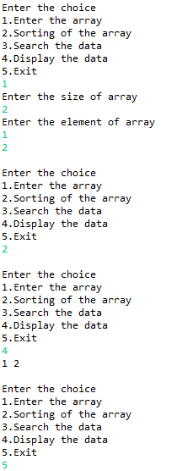

Name:- Yashraj Vijay Aware

PRN no:- 22110167

Roll No.:-224006

Div:-D

Div.:-D1